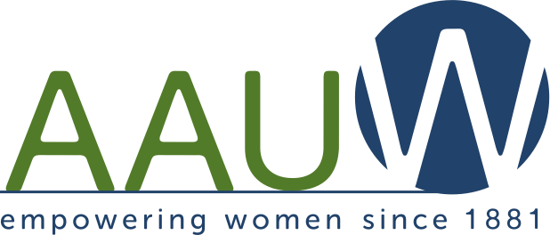
Iowa Branch Connector

February 2017

A Monthly Electronic Bulletin for AAUW Leaders in Iowa
The Value of Affiliation with AAUW: By joining AAUW, you belong to a community that breaks through educational and economic barriers so that all women have a fair chance.

Welcome to this monthly electronic publication. You are invited to share this information with other members and branch leaders by forwarding it to them or providing a hard copy.

Ann Gale, AAUW Iowa President 2016-18
Apathy or Action
Maureen White, AAUW Iowa Public Policy Director

Kathy Obradovich wrote an evocative sentence in her January 24 Des Moines Register column about the Women’s March, “As a longtime political reporter and columnist who tries to encourage citizen participation, I’m used to beating my wings against the cold window of apathy.” How many of us have wings today that are feeling a little torn?

We members of AAUW who care about the welfare of women, girls and families no longer have the luxury of apathy. The newly installed administration in Washington DC and the Iowa legislature are taking measures that can turn back the hard-won progress achieved in past years.
- The U.S. secretary of education nominee knows little about public education, including special education laws that have been on the books since 1975, and does not appear to support Title IX enforcement. Public education, the bedrock of an educated citizenry and the path toward a better life for many, could be starved of funding under a secretary who has only worked as a champion of charter schools and home schooling. We face the same dangers in Iowa.
- The administration is planning to spend time and our tax money to investigate non-existent voter fraud. Women fought long and hard for the right to vote, which now could be denied for those without a required ID or who don’t meet some other requirement. In Iowa, those who commit any type of felony, 85% if which are non-violent offenses, already lose their right to vote and there are other proposals that effectively restrict access to voting.
- The administration is likely to attempt to slash funding for the U.N. and prohibit the U.S. from entering into treaties such as CEDAW, the Convention on the Elimination of Discrimination Against Women.
- The administration is talking about over-turning requirements for improved automobile fuel-efficiency standards, ramping up use of fossil fuels rather than clean energy, and is likely to ignore international climate accords. These are economic, security, and health issues for all.
- The Administration and Congress want to take away health care for millions of people by repealing the Affordable Care Act rather than just fixing the problems.
- It is likely nothing will happen with the public health issue of sensible gun safety legislation that would help protect citizens (including school children) from gun violence. Iowa legislators have proposed even looser regulations than we have now.
- Efforts to defund Planned Parenthood, to restrict access to contraceptives or safe, legal abortion are cloaked as “protecting the health of women”, as if women don’t have the sense to make their own decisions about if and when to have children. The administration has already signed an order that will prevent international agencies that get any federal funding from even talking about reproductive choices, let alone providing those options, anywhere they work around the world.
- We don’t know yet what will happen with criminal justice reform initiatives or those children who were brought here without documentation. The list of unknowns could go on.

So what do we AAUW members do? Many of you are longtime activists, some not so much. AAUW is a non-partisan organization, but is involved in advocacy around issues that are of their nature political. Politics is the means for citizens to shape the direction of their government. We need to get political.
- If you have not already, sign-up for the Action Network at www.aauw.org to be informed about federal issues and to make your voice heard.
- Attend the AAUW Iowa Lobby day on February 22 at the Capitol.
- Sponsor, or attend local meetings or forums with legislators and speak up.
- If AAUW Iowa asks you to contact legislators about bills related to our public policy, please take a few minutes to do so.
- Email, call, or write your legislators about issues that are especially important to you. Branch presidents and public policy directors have received tips for communicating with legislators that they can share with all members.
- Become a public policy director if your branch doesn’t have one.
- Include time for advocacy and action discussions at branch meetings or events.
- Include issue advocacy articles in branch newsletters or other communications.
- To date there are over 150 bills introduced in the Iowa Senate and over 130 in the House–too many to list here. But right now we recommend you:
  - Ask your legislators to support a $250,000 appropriation for the Center for Violence Prevention and the Governor’s Office for Bullying Prevention at the UNI, which provide training for schools and communities.
  - Ask your legislators to support SF 66 which would require employers to provide reasonable accommodations for pregnant workers.
  - Ask your legislators to oppose efforts to defund Planned Parenthood, including SF 2 and other bills to restrict access to reproductive health care.

AAUW Iowa recognizes that a volunteer organization like ours must work with others to achieve common goals, so our board approved involvement with the Iowa Justice Action Network, Moral Mondays, a gun safety coalition, and a voting rights coalition. Within those coalitions we only advocate on issues related to our AAUW public policy. Our priorities also align in some respects with groups like the League of Women Voters of Iowa, the NAACP, and the Iowa Commission on the Status of Women. You could explore ways to work with like-minded groups such as these in your community.

AAUW Iowa encourages women to seek appointment to boards and commissions and we support the work of 50-50 in 2020, a group focused on proportional representation of women in elected office.

Whether or not we always succeed in changing hearts and minds, there are plenty of ways to take action.

