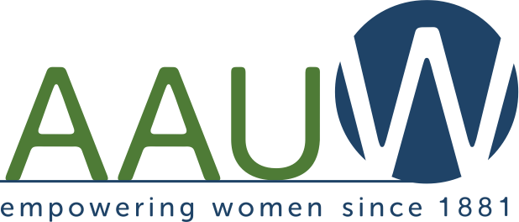
Iowa Branch Connector

August 2016

A Monthly Electronic Bulletin for AAUW Leaders in Iowa
The Value of Affiliation with AAUW: By joining AAUW, you belong to a community that breaks through educational and economic barriers so that all women have a fair chance.

Welcome to this monthly electronic publication. You are invited to share this information with other members and branch leaders by forwarding it to them or providing a hard copy.

Ann Gale, AAUW Iowa President 2016-18
Save the Date
The 2017 AAUW Iowa State Conference is scheduled for Saturday, April 29 and Sunday, April 30 in Cedar Rapids. Details will be provided at a later date. Please mark these dates on your branch calendar and begin making plans to meet with your fellow AAUW members in Cedar Rapids

The following article is written by Membership Vice President Elaine Kresse and College University Relations Director Janet Fife-Lafrenz.

College/University Partner Membership Offers a Lot of Benefits
AAUW has been empowering women as individuals and as a community since 1881. For more than 130 years, we have worked together as a national grassroots organization to improve the lives of millions of women and their families.

AAUW advances equity or women and girls through advocacy, education philanthropy and research. Our vision is simple – we bring people together united behind the common goal of breaking though educational and economic barriers.

Therefore, the membership and college and university partner committees have opted to work as a team to grow membership in AAUW statewide. TWO for the price of ONE …. WHAT A DEAL!!!!

The C/U partner member program provides many benefits to institutions of higher learning. Below are a few of the many benefits:
- Free e-student affiliate memberships for all undergraduates/community college students at a participating college whether private or public.
- Priority for educational project grants and leadership development opportunities for students.
- The ability to list employment opportunities at the AAUW Career Center.
- Access to AAUW internships in Washington, D.C.
- Opportunities for faculty to participate in national selection panels for prestigious awards
- Access for staff and faculty to use AAUW Programs in a Box to supplement teaching and programming in the classroom.

The annual fee for membership regardless of the institutions size is $125 for new members and $175 for continuing members. Memberships run from July 1 through June 30.

Just look on the AAUW website and see all we do nationally and internationally: research, campus leadership, stem, public policy, case support, educational funding, global connections, leadership, and salary negotiations.

With all that said, and it’s impressive, the key is in the second sentence above. “…we have worked together as a national grassroots organization.” We are the grassroots and we are AAUW’s strength and future.

And so the mission and vision of the membership committee is inclusion and growth. State wide we have 27 branches. Can we make that 30? State wide we have 756 members. Can we make that 800? How will we do that? We are asking each branch membership chair to ask their branches these questions.
1. Are there colleges close by that are c/u members? If not, why not? Have you talked with them?
2. If a school is an AAUW affiliate have you invited the representative to join at the state and local level?
3. Are there young women at that institution who would like to be student affiliates?
4. Have you considered adding a Young Woman’s Task Force to your branch?

Looking at the staff and students at our local colleges and universities is only one way to strengthen us. You can supply many other ways to grow to ensure our future in Iowa.

We are so looking forward to being of service to you as you find your ways to reach out and grow.

Elaine Kresse  Membership Vice President  elainekresse2@gmail.com | Janet Fife-LaFrenz  College/University Relations Director  fifelafrenz@gmail.com

