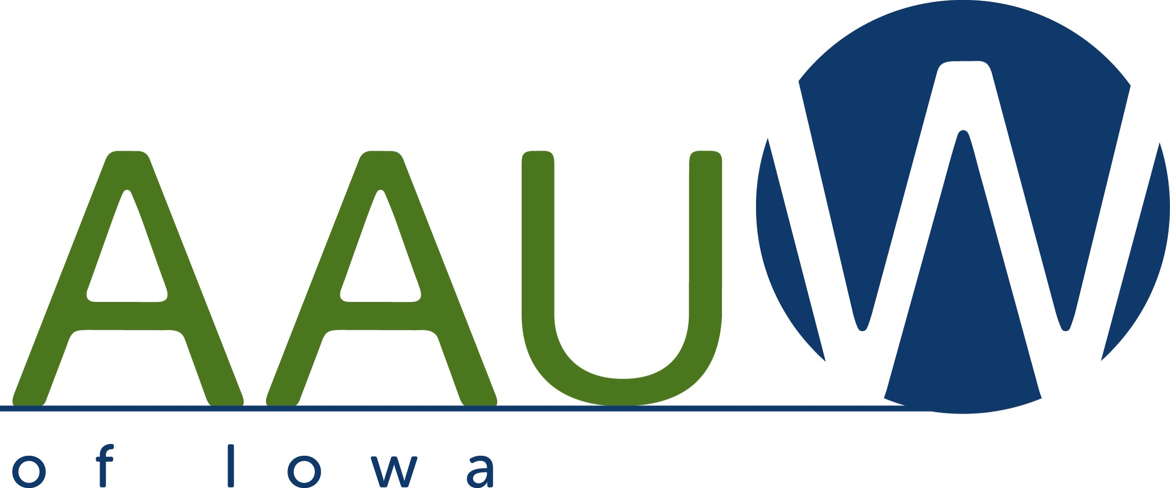

AAUW Iowa Public Policy Program 2018-20
The Mission of AAUW is to advance equity for women and girls through advocacy, education, philanthropy and research.
AAUW Iowa endorses the AAUW Public Policy Program, Principles for Action and Biennial Action Priorities, which can be found on-line at www.aauw.org.
Iowa’s Public Policy Program is intended to complement that of AAUW and be a focus of active educational and advocacy efforts for our members. The program can be found on-line at http://aauw-ia.aauw.net/publicpolicy/public-policy-program

To promote a strong system of public education and lifelong learning that promotes gender fairness, equity, and diversity, AAUW of Iowa advocates:
- Adequate and equitable funding of public education, preschool through post secondary; including full funding of mandated programs, as well as programs such as counseling and the visual and performing arts.
- Affordable public community college, college and university tuition and provision of programs that help women or disadvantaged students access higher education.
- Opposition to use of public funding for non-public, charter, or home schools that do not meet the civil rights and accountability standards required of public schools and educators.
- Availability and adequate funding for sexual health education and programs that expand opportunity for girls, including science, technology, engineering and math (STEM) education.
- Vigorous enforcement of Title IX and other civil rights laws that prohibit discrimination or harassment at all levels of education; making schools safe for all students, regardless of gender, race, religious affiliation, disability, sexual orientation, and gender identity or expression.

To achieve economic self-sufficiency for all women, AAUW of Iowa advocates:
- Pay equity and fairness in public and private employment compensation and benefits.
- Equitable opportunities for workplace advancement, including training opportunities, and enforcement of sex/gender bias and anti-discrimination statutes.
- Workplace policies that promote work-life balance, including quality affordable dependent care, adequate family and medical leave, flexible hours, and provisions for pregnant workers or new mothers.
- Collective bargaining rights for public or private sector employees and the right of workers to unionize without employer intimidation or reprisal.
- Funding for facilities and programs designed to transition women from the criminal justice system back to their communities, including employment training and education.
- Protecting and strengthening retirement benefits and programs, including state run retirement programs.

To guarantee gender equality, individual rights, and social justice for a diverse society, AAUW of Iowa advocates:
- Measures that protect, facilitate, and expand the right of all citizens to vote.
- Equitable representation of women and minorities in elected, appointed, policy making, and judicial positions.
- Support and funding for programs to prevent hate crimes and violence against women and children in homes, schools, the workplace, and communities, including gun violence, and to address the needs of victims of violence.
- Rigorous enforcement of laws against human trafficking and support for programs to aid trafficking victims.
- Access to public education and basic health and safety programs, without unreasonable requirements for proof of citizenship or other provisions beyond those included in Federal law.
- Increased access to quality, affordable family planning services and physical and mental health care within a reasonable distance; including prescription medication coverage, and addictive substance education, prevention and treatment programs.
- The right of a woman to make decisions regarding her reproductive life without intrusive or restrictive government regulations, including the targeted regulation of abortion providers.
- Protection of the elderly through strict enforcement of nursing home regulations and stiff fines for violators.

